
THE BOOK OF ROMANS
“Through Him we have received grace and apostleship for obedience to the faith among all nations for His name, among whom you also are the called of Jesus Christ….”

Romans 1:5-6

Chapter 1 and 2
‘Who is Greece?’

Most of the recap study portion does not involve this worksheet. We will jump into this the next study!

Let’s look at a map at where Assyria is and what mountains are right next to it.

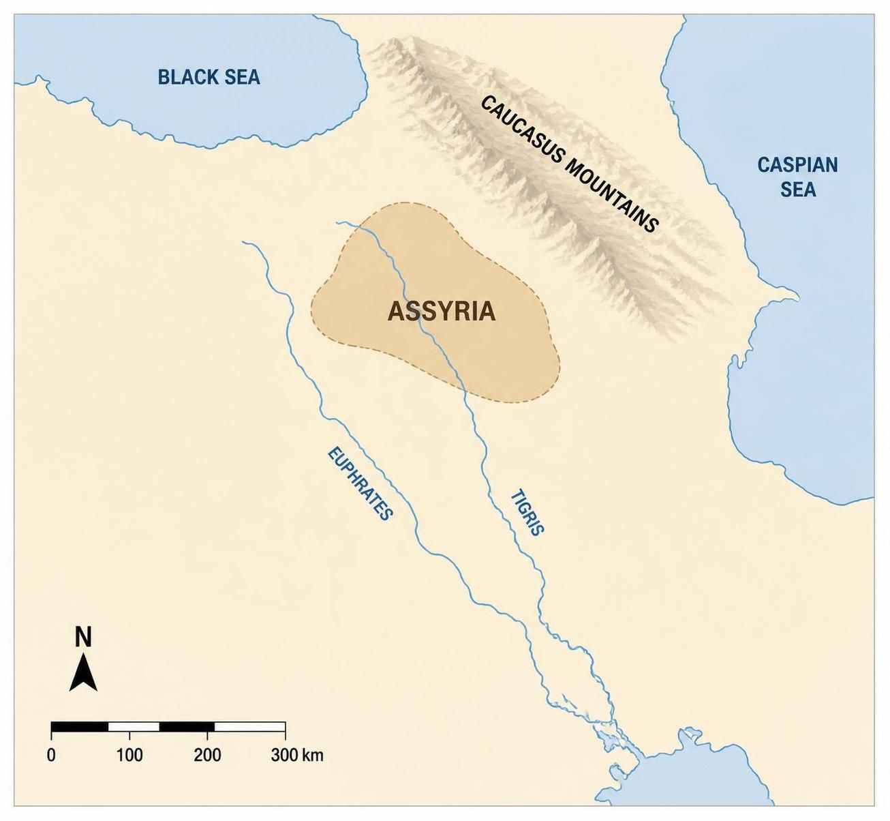

John 19:19-20 ¹⁹ Now Pilate wrote a title and put it on the cross. And the writing was:
JESUS OF NAZARETH, THE KING OF THE JEWS.
²⁰ Then many of the Jews read this title, for the place where Jesus was crucified was near the city; and it was written in Hebrew, Greek, and Latin. This represents the House of Judah, the House of Israel, and the Gentiles. He’s King of us all - but we must be grafted in first. Even the “wild” olive tree (original tribes) MUST be grafted in again through Jesus - there is no other way to the Father.

Okay - so the 10 tribes were exiled into this realm by Assyria. And Assyria is used as a parabolic word for this realm. And which people group does not have a clue where they came from, but we know they

came over the Caucasus mountains?

We’ve set the stage. So, who are the New Covenant scriptures predominately speaking about?

_____________________ , Because, who did Jesus say he was sent for?

_______________________________. Therefore, it’s a bunch of

law abiding people, sent to fish for what “son”? ___________________________

- 1:1-2 “Paul, a bondservant of Jesus Christ, called to be an apostle, separated to the gospel of GOD which He promised before through HIS prophets in the Holy Scriptures,”. Paul states who he is and that he is separated to the ________________ of GOD which He promised through His

________________________________ Right out of the gate, Paul is pointing to the prophets in the holy scriptures as to how he is going to understand what is happening in his present day. He doesn’t say, “It’s time to put on our Greco/Roman thinking caps!” Although he will speak to them differently to try and reach them, he will not bend to their culture. He’s going to interpret what has happened in his day and what it means for the future, utilizing the holy scriptures. He’s going to showcase the divorce certificate and what Jesus means for these people.

Romans 1:3-4 “concerning HIS Son Jesus Christ our Lord, who was born of the seed of David according to the flesh, and declared to be the Son of GOD with power according to the Spirit of holiness, by the resurrection from the dead”. Paul tells us that the prophets concern the

__________________. Then Paul proves his point by using prophesy to describe the Messiah, 1:4, “concerning His Son Jesus Christ our Lord, who was born of the seed of David according to the flesh, and declared to be the Son of God with power according to the Spirit of holiness, by the resurrection from the dead.” And let’s look at Acts 3:18 “But those things which GOD foretold by the mouth of all HIS prophets, that the Messiah would suffer, He has thus fulfilled”.

- 1:5 “Through Him we have received grace and apostleship for obedience to the faith among all nations for His name”. Through Christ, through Him, what have we received?

____________________________________ For what?

____________________________

- 1:6-7 “among whom you also are the called of Jesus Christ; to all who are in Rome, beloved of GOD, called to be saints:” He goes on to say, “among all nations for His name, among whom you also are the called of Jesus Christ; to all who are in Rome, beloved of God, called to be saints.” Is this message

for the entire nation of Rome? ___________

- 1:16-32 For the wrath of GOD is revealed from heaven against ungodliness and unrighteousness of men, who suppress the truth in unrighteousness, because what may be known of GOD is manifest in them, for GOD has shown it to them (right here we see GOD is addressing the House of Israel, who was given the divorce certificate some 400 years before. They suppress the truth they ONCE had or Godliness, and forgot who they were and where they came from. For since the creation of the world His invisible attributes are clearly seen, being understood by the things that are made, even His eternal power and Godhead, so that they are without excuse, because, although they knew GOD these were once people of GOD, they did not glorify Him as GOD, nor were thankful, but became futile in their thoughts, and their foolish hearts were darkened. Professing to be wise, they became fools. GOD is describing the House of Isael before they received the divorce certificate. Let’s look at Acts 7 42-43 and skip to Acts 7:51-53.

Now let’s continue with Romans 1:23 And changed the glory of the incorruptible GOD into an image made like corruptible man - and birds and four-footed animals and creeping things. The Gentiles that the House of Israel is living amongst now, is described in Peter’s vision of the sheet coming down in Acts as birds, four-footed animals and creeping things. So now we are told who the House of Israel lives among – they live among the Gentiles who are corruptible men - but remember, GOD says to call nothing unclean that HE has made clean. Meaning HE can even make the heathen, or the Gentile clean through His perfect Law and the washing away of their sins through Jesus. Therefore GOD also gave them up to uncleanness we come back to the House of Israel, to practices of the Godless, in the lusts of their hearts he is addressing the covenant people - meaning the first covenant, to dishonor their bodies among themselves, who exchanged the truth of GOD for the lie, and worshiped and served the creature rather than the Creator, who is blessed forever. Amen. For this reason, GOD gave them up to vile passions. For even their women exchanged the natural use for what is against nature. Likewise, also the men, leaving the natural use of the woman, burned in their lust for one another, men with men committing what is shameful, and receiving in themselves the penalty of their error which was due. And even as they did not like to retain GOD in their knowledge, GOD is talking to a people who once had the knowledge of GOD, but did not want to keep it, gave them over to a debased mind, to do those things which are not fitting lawless; being filled with all unrighteousness, wickedness, covetousness, maliciousness, full of envy, murder, strife, deceit, evil mindedness, they are whisperers, backbiters, haters of GOD, violent, proud, boasters, inventors of evil things, disobedient to parents, undiscerning, untrustworthy, unloving, unforgiving, unmerciful, who knowing the righteous judgement of GOD that those who practice such things are deserving of death, not only do the same but also approve of those who practice them.

- Acts 9:15 “But the Lord said to him, “Go, for he is a chosen vessel (Jesus speaking of Paul) of Mine to bear My name before Gentiles, kings, and the children of Israel.” Here, Jesus is telling us who and where Paul is sent to, and it’s three different groups for three different reasons.

First, we see the word Gentiles. What does this word mean? ____________

Let’s look at Ezekiel 36:16-38 “Moreover the word of the Lord came to me, saying: son of man, when the House of Israel dwelt in their own land, they defiled it by their own ways and deeds; to me their way was like the uncleanness of a woman in her customary impurity. Therefore, I poured out my fury on them for the blood they had shed on the land, and for their idols with which they had defiled it. So, I scattered them among the nations, and they were dispersed throughout the countries Gentiles; I judged them according to their ways and their deeds. When they came to the nations, wherever they went, they profaned my holy name, when they said of them (the people in these nations), these are the people of the LORD, and yet they have gone out of His land. Remember - nations are Abrahamic people groups. But I had concern for my holy name, which the House of Israel had profaned among the nations wherever they went. Therefore, say to the House of Israel, thus says the LORD GOD: I do not do this for your sake, O House of Israel, but for my holy name's sake, which you have profaned among the nations wherever you went. And I will sanctify my great name, which has been profaned among the nations, which you have profaned in their midst; and the nations shall know that I am the Lord, says the LORD GOD, when I am hallowed in you before their eyes. For I will take you from among the nations, gather you out of all countries another way to say this realm - or “coastlands”, and bring you into your own land this won’t happen until the end times. Then I will sprinkle clean water on you, and you shall be clean; I will cleanse you from all your filthiness and from all your idols. I will give you a new heart and put a new spirit within you; I will take the heart of stone out of your flesh and give you a heart of flesh. I will put my spirit within you (in this realm, we need the Spirit of GOD - this is the valley of the shadow of death) and cause you to walk in my statutes and you will keep my judgments and do them This is due to the fact they do not follow the Way – or the laws of GOD. Then you shall dwell in the land that I gave to your fathers; (Zion) You shall be my people, and I will be your GOD. I will deliver you from all your uncleanness. I will call for the grain and multiply it and bring no famine upon you. And I will multiply the fruit of your trees and the increase of your fields, so that you need never again bear the reproach of famine among the nations. Then you will remember your evil ways and your deeds that were not good; And you will loathe yourselves in your own sight, for your iniquities that word means lawlessness and your abominations. Not for your sake do I do this, says the LORD GOD, let it be known to you. Be ashamed and confounded for your own ways, O House of Israel! Thus says the Lord God: on the day that I cleanse you from all your iniquities, I will also enable you to dwell in the cities, and the ruins shall be rebuilt. The desolate land shall be tilled instead of lying desolate in the sight of all who passed by. So they will say, this land that was desolate has become like the garden of Eden; And the wasted desolate, and ruined cities are now fortified and inhabited. Then the nations which are left all around you shall know that I, the Lord, have rebuilt the ruined places and planted what was desolate. I, the Lord, have spoken it, and I will do it. Thus says the Lord God: I will also let the House of Israel inquire of me to do this for them: I will increase their men like a flock. Like a flock offered as holy sacrifices, like the flock at Jerusalem on its feast days, so shall the ruined cities be filled with flocks of men. Then they shall know that I am the Lord.” What we can see here is the House of Israel is going to be redeemed by Jesus when he fulfills the divorce certificate, and will be permitted to return to the land. And GOD is concerned about how all this looks in the sight of the nations.

Second, we see the word kings. Let’s look at what Jesus says in Matthew 10:16-20. “Behold, I send you out as sheep in the midst of wolves. Therefore, be wise as serpents be as wise as those who deceive you and harmless as doves. But beware of men, for they will deliver you up to councils and scourge you in their synagogues. You will be brought before governors and kings (people in politics/world leaders) for My sake, as a testimony to them and to the Gentiles (where the House of Israel has been scattered). But when they deliver you up, do not worry about how or what you should speak (Do these kings sound like they are called by Jesus Christ and called to be saints?). For it will be given to you in that hour what you should speak ‘hour’ is time stamp vocabulary for the end times; for it is not you who speak, but the Spirit of your Father who speaks in you.” This is what it means for Paul to go before kings and to Gentiles as a testimony. He is sent to where the House of Israel has been scattered to - as a witness and a testimony.

Third, and lastly, Romans mentions, “to the House of Israel”. That’s peculiar, why doesn’t he mention the House of Judah? Because they aren’t here! Let’s look at Matthew 24:15

These twelve Jesus sent out and commanded them (this is who the disciples are commissioned to), saying: “Do not go into the way of the Gentiles, and do not enter a city of the Samaritans. But go rather to the lost sheep of the house of Israel. And as you go, preach, saying, ‘The kingdom of heaven is at hand.’ Heal the sick, cleanse the lepers, raise the dead, cast out demons. Freely you have received, freely give. Provide neither gold nor silver nor copper in your money belts, nor bag for your journey, nor two tunics, nor sandals, nor staffs; for a worker is worthy of his food.”

- Romans 1:13 “Now I do not want you to be unaware, brethren, that I often planned to come to you (but was hindered until now), that I might have some fruit among you also, just as among the other Gentiles. I am a debtor both to Greeks and to the barbarians, both to wise and to unwise.” Do you see how the Greeks and barbarians are two different groups? The barbarians are the same as saying Gentiles, and the

Greeks, I’m going to show you, is the same as saying __________________________

- So does this mean that the gospel is only for the House of Israel? No. Let’s look at v. 14. I am a debtor both to Greeks (House of Israel) and to barbarians (Gentiles), both to wise those who already know the Creator and to unwise those who do not. So, as much as is in me, I am ready to preach the gospel to you who are in Rome also. We see that Paul is commissioned to the “Gentiles” - meaning this realm - and they will be given hope through the gospel as well.

- Romans 1:16-17 Verse 16 gets interesting. “For I am not ashamed of the gospel, (they added of Christ), for it is the power of God to salvation of everyone who believes, for the Jew first (House of Judah – remember, they were not given a divorce certificate and this includes the 2 tribes of Judah, Benjamin and (Levy)) and also for the Greek (House of Israel (10 tribes) – and we are going to see in the coming scriptures why this makes sense. Also – it is believed that Luke was Greek and Jesus would not have taken a disciple unless he was from the House of Judah or the House of Israel - a disciple cannot be a Gentile. They would not have understood the Messiah prophesies. Also, the first scriptures were written in Hebrew/Aramaic and then Greek – the Septuagint. Therefore, although we’ve been taught the Greeks are Gentiles, they are not! The divorce certificate concerned the House of Israel). Let’s continue with v. 17 “For in it the righteousness of God is revealed from faith to faith; as it is written, “The just shall live by faith.” This is a verse in Habakkuk, which I believe is all about keeping your faith while being cast into this demonic, sickly realm! Let’s read Habakkuk 1:2-17 to 2:1-4.

Habukkuk 1:2-17 through 2:1-4 O Lord, how long shall I cry,
And You will not hear? Even cry out to You, “Violence!” And You will not save. ³ Why do You show me iniquity lawlessness, And cause me to see trouble? For plundering and violence are before me; There is strife, and contention arises. ⁴ Therefore the law meaning the blessings of the law because there are blessings and there are curses is powerless, And justice never goes forth. For the wicked surround the righteous; Therefore perverse judgment proceeds. The Lord’s Reply ⁵ “Look among the nations and watch— Be utterly astounded! For I will work a work in your days Which you would not believe, though it were told you. ⁶ For indeed I am raising up the Chaldeans the first example given is the Babylonians and they exiled the House of Judah - but they are used as an example of what GOD’s mighty nations (still Shem people group), will be like over in this realm. They will be mighty and lack GOD., A bitter and hasty nation Which marches through the breadth of the earth, To possess dwelling places that are not theirs. ⁷ They are terrible and dreadful; Their judgment and their dignity proceed from themselves. ⁸ Their horses also are swifter than leopards, And more fierce than evening wolves. Their ^{[b]}chargers ^{[c]}charge ahead; Their cavalry comes from afar; They fly as the eagle that hastens to eat. ⁹ “They all come for violence; Their faces are set like the east wind. They gather captives like sand. ¹⁰ They scoff at kings, And princes are scorned by them. They deride every stronghold For they heap up earthen mounds and seize it. ¹¹ Then his ^{[d]}mind changes, and he transgresses; He commits offense, Ascribing this power to his god.”
The Prophet’s Second Question ¹² Are You not from everlasting, O Lord my God, my Holy One?
We shall not die. O Lord, You have appointed them for judgment; O Rock, You have marked them for correction. ¹³ You are of purer eyes than to behold evil, And cannot look on wickedness. Why do You look on those who deal treacherously, And hold Your tongue when the wicked devours A person more righteous than he? They are talking about the wicked the nations of Shem - they are still a powerful power. When you think of Africa, or where Ham predominately comes from, they are not powerful. However, the line of Shem is powerful. Remember - Abraham came from here. ¹⁴ Why do You make men like fish of the sea, Like creeping things that have no ruler over them? ¹⁵ They take up all of them with a hook, They catch them in their net, And gather them in their dragnet. Therefore they rejoice and are glad. ¹⁶ Therefore they sacrifice to their net, And burn incense to their dragnet; Because by them their share is sumptuous And their food plentiful. ¹⁷ Shall they therefore empty their net, And continue to slay nations without pity? 2:1-4 I will stand my watch And set myself on the rampart, And watch to see what He will say to me, And what I will answer when I am corrected. ² Then the Lord answered me and said: “Write the vision. And make it plain on tablets, That he may run who reads it. ³ For the vision is yet for an appointed time; But at the end it will speak meaning what GOD is going to do in the end times by bringing HIS people back to HIS land and away from all that was just mentioned, and it will not lie. Though it tarries, wait for it; Because it will surely come, It will not tarry. ⁴ “Behold the proud, His soul is not upright in him; But the just shall live by his faith. This is what Paul just used in Romans. I think this means that while we wait for the “appointed time” prophesied in Habakkuk, while we are exiled and wait for this to happen and not tarry, and cannot see the other realm and how amazing it is - we are called to live by faith.

- The Book of Romans will now address the House of Israel and the House of Judah! Let’s read chapter 2 and we will break it down as we go.
“Therefore you are inexcusable, O man, whoever you are who judge, for in whatever you judge another you condemn yourself; for you who judge practice the same things. GOD is addressing the House of Israel who judge, but are practicing the ways of the Gentiles ² But we know that the judgment of God is according to truth against those who practice such things. ³ And do you think this, O man, you who judge those practicing such things, and doing the same, lawlessness that you will escape the judgment of God? Just because you’re from the House of Israel or Judah does not give you a pass. ⁴ Or do you despise the riches of His goodness, forbearance, and longsuffering, not knowing that the goodness of God leads you to repentance? For practicing lawlessness ⁵ But in accordance with your hardness and your impenitent heart you are treasuring up for yourself wrath in the day of wrath and revelation of the righteous judgment of God, ⁶ who “will render to each one according to his deeds”: ⁷ eternal life to those who by patient continuance in doing good seek for glory, honor, and immortality; ⁸ but to those who are self-seeking and do not obey the truth, but obey unrighteousness—indignation and wrath, ⁹ tribulation and anguish, on every soul of man who does evil, lawlessness of the Jew first House of Judah - because they understand more, they will be held accountable more and also of the Greek House of Israel - they know more than the heathen or the Gentile; ¹⁰ but glory, honor, and peace to everyone who works what is good, to the Jew first House of Judah - were not given the divorce certificate due to lawlessness - and must help bring the House of Israel back into the fold and also to the Greek House of Israel - called by GOD - but practiced lawlessness. ¹¹ For there is no partiality with God. ¹² For as many as have sinned without law will also perish without law House of Israel, and as many as have sinned in the law House of Judah, will be judged by the law ¹³ (for not the hearers of the law are just in the sight of God, but the doers of the law will be justified; ¹⁴ for when Gentiles barbarians - the third group, who do not have the law, by nature do the things in the law they don’t practice adultery, they take care of their parents, they give to the poor, these, although not having the law, are a law to themselves, ¹⁵ who show the work of the law written in their hearts, their conscience also bearing witness, and between themselves their thoughts accusing or else excusing them even Gentiles will see that murder is wrong or stealing, but the seed of the serpent predominately does not) ¹⁶ in the day when God will judge the secrets of men by Jesus Christ, according to MY gospel. ¹⁷ Indeed you are called a Jew, and rest on the law, and make your boast in God, ¹⁸ and know His will, and approve the things that are excellent, being instructed out of the law, ¹⁹ and are confident that you yourself are a guide to the blind, a light to those who are in darkness, ²⁰ an instructor of the foolish, a teacher of babes, having the form of knowledge and truth in the law. House of Judah ²¹ You, therefore, who teach another, do you not teach yourself? You who preach that a man should not steal, do you steal? ²² You who say, “Do not commit adultery,” do you commit adultery? You who abhor idols, do you rob temples? ²³ You who make your boast in the law, do you dishonor God through breaking the law? ²⁴ For “the name of God is blasphemed among the Gentiles because of you,” as it is written. This is exactly what goes on today - Christians are very much hypocrites because they stand on some laws, but not on all of them. They say homosexuality is against the law, but eat their swine or their shellfish. They do what suits them, and it blasphemes the name of GOD amongst those who are perishing. ²⁵ For circumcision is indeed profitable if you keep the law; but if you are a breaker of the law, your circumcision has become uncircumcision. We can circumcise our sons all we want - but if we don’t follow the whole law - what good is a physical circumcision when the heart isn’t circumcised into obedience? ²⁶ Therefore, if an uncircumcised man keeps the righteous requirements of the law, will not his uncircumcision be counted as circumcision? Amazing - GOD cares more about HIS law than HE does a physical indication of it - which without the law, means nothing. This is why there is an argument in Acts if the Gentiles MUST be circumcised and the answer was no - not out of the gate. ²⁷ And will not the physically uncircumcised, if he fulfills the law, judge you who, even with your written code man-made traditions of what is righteous and circumcision, are a transgressor of the law? ²⁸ For he is not a Jew who is one outwardly, nor is circumcision that which is outward in the flesh; ²⁹ but he is a Jew who is one inwardly the law is on his heart and he is obedient; and circumcision is that of the heart circumcision of the heart is much more important than circumcision of the flesh – a man robs a bank and is circumcised, means that his circumcision will mean nothing, in the Spirit, not in the letter circumcision is of the letter - which we were just told means nothing without the law - this is not talking about the whole of the law, it’s addressing circumcision because this was a huge contention between the Jews and how to handle new believers; whose praise is not from men but from God. And we will see in scriptures where they argue that Abraham was not circumcised when he first became a believer and followed GOD. His obedience was still counted for him.

https://www.youtube.com/watch?v=1Xv4dfk3yB4&list=PLgOZA3Y6EEe7fm5bktYNgaK7fa_vt3KW9&index=1&t=317s

